***Paragraph***

The primary purpose of this code was to provide a smooth and “nice” looking program, with easy use and smooth Menus, while still remanning within the realm of using the Terminal. I believe I have pulled this off relatively well, with the Menu screen remaining smooth and easy to understand program. The Program opens with a splash screen made of Ascii Art, with the Title “Sally’s Seaside Travel” being shown in large Ascii letters, and a small image showing a beach scene with the sun rising. The Text within the waves reads “Start Your Holiday Today!!; Press Any key to start. The Program then waits for the User input. Once the user inputs literally anything the Program shows a scrollable menu, with the users being able to chose between options of Hotels by using the W and S key to navigate, once a hotel is selected, the enter key must be pressed where the program enters into a part where the user inputs the info about their holiday. After this the program calculate the costs, the program spits out both the day costs as well as the total cost, before booting back to another screen, where the user can leave the program by inputting 0 or press any other key to continue and restart the program.

The Program proper works between layers of Loops, the Largest, and the main loop is Mother_of_All_Variables. This one will loop between the 2 main loops within the program. Outside of this are Start-up parts of the Program, and the Programs Splash Screen. Within Mother_of_All_variables loop there is 2 main settings of the Loop_On variables. When it is equal to 1 it runs a hotel selection loop, where the user can scroll between a selection of restaurants. W/S are used to scroll up/down to select their Hotel of choice. The User Input is entered outside of the if statement to allow further optimisation. The program also detects if its more or less than the actual amount of selections, so the program won’t break, and the Menu will still function. This is the main problem within the program, as for some reason the Menu_Select variable would become equal to 1.0000000000002 for no particular reason, this obviously corrupt number is overcome pretty easily via the use of some else statements, however, if it is still in the first nested loop of Hotel selection it will display a blank screen. Once “enter” is pressed it changes Loop_On to equal 2. This puts the user in the second nested loop of the Program.

Within this part of the 2 main loops the user can input their details of their holiday. After this, the program accounts for the hotel the user previously selected and calculates the amount the user would have to spend to go on the holiday. The user is then presented with the option of exiting the program, or restarting again and attribute Loop_On = 1

***Pesudo Code of Sally’s Seaside Program***

* Loop_On = 1
* Mother_of_all variables = 1
* Menu_Select = 1
* var = 0
* days = 0
* kids = 0
* Exit = 0
* Adult Cost = 0
* Kids Cost = 0
* Day Cost = 0
* Total Cost = 0
* Display: _____ _ _ _____ _ _ _______ _
* / ____| | | | / ____| (_) | | |__ __| | |
* | (___ __ _| | |_ _ ___ | (___ ___ __ _ ___ _ __| | ___ | |_ __ __ ___ _____| |
* \___ \ / _` | | | | | / __| \___ \ / _ \/ _` / __| |/ _` |/ _ \ | | '__/ _` \ \ / / _ \ |
* ____) | (_| | | | |_| \__ \ ____) | __/ (_| \__ \ | (_| | __/ | | | | (_| |\ V / __/ |
* |_____/ \__,_|_|_|\__, |___/ |_____/ \___|\__,_|___/_|\__,_|\___| |_|_| \__,_| \_/ \___|_|
* __/ |
* |___/
* ,. _~-., .
* ~'`_ \/,_. \_
* / ,"_>@`,__`~.) | .
* | | @@@@' ",! . . '
* |/ ^^@ .! \ | /
* `' .^^^ ,' ' | . .
* .^^^ . \ / .
* .^^^ ' . \ | / . '
* .,.,. ^^^ ` . .,+~'`^`'~+,. , '
* &&&&&&, ,^^^^. . ._ ..__ _ .' '. '_ __ ____ __ _ .. . .
* %%%%%%%%%^^^^^^%%&&;_,.-=~'`^`'~=-.,__,.-=~'`^`'~=-.,__,.-=~'`^`'~=-.,
* &&&&&%%%%%%%%%%%%%%%%%%&&;,.-=~'`^`'~=-.,__,.-=~'`^`'~=-.,__,.-=~'`^`'~=
* %%%%%&&&&&&&&&&&%%%%&&&_,.;^`'~=-.,__,.-=~'`^`'~=-.,__,.-=~'`^`'~=-.,__,
* %%%%%%%%%&&&&&&&&&-=~'`^`'~=-.,__,.-=~'`^`'~=-.,__,.-==--^'~=-.,__,.-=~'
* ##mjy#####*"'
* _,.-=~'`^`'~=-Start your Holiday Today!!!`^`'~=-.,.-=~'`^`'~=-.,__,.-=~'
* Press Any ket to start seeing Offers
* ~`'^`'~=-.,__,.-=~'`^`'~=-.,__,.-=~'`^`'~=-.,__,.-=~'`^`'~=-.,__,.-=~'`^
* User Input = Var
* Clear Display
* Is Mother of all Variables = 1?:
  + Is Loop_on = 1?
    - Is Menu_Select = 1?
      * Display: Select your Hotel!
      * [X] Basils Backpackers
      * [ ] Ocean Breeze Units
      * [ ] Silver Sands Hotel
      * [ ] Capricorn Club
      * [ ] Sunset Ridge Resort
      * Use W/S to go Up/Down
      * Menu_Select = Menu_Select + 0.2
    - Is Menu_Select = 2?
      * Display: Select your Hotel!
      * [ ] Basils Backpackers
      * [X] Ocean Breeze Units
      * [ ] Silver Sands Hotel
      * [ ] Capricorn Club
      * [ ] Sunset Ridge Resort
      * Use W/S to go Up/Down
      * Menu_Select = Menu_Select + 0.2
    - Is Menu_Select = 3?
      * Display: Select your Hotel!
      * [ ] Basils Backpackers
      * [ ] Ocean Breeze Units
      * [X] Silver Sands Hotel
      * [ ] Capricorn Club
      * [ ] Sunset Ridge Resort
      * Use W/S to go Up/Down
      * Menu_Select = Menu_Select + 0.2
    - Is Menu_Select = 4?
      * Display: Select your Hotel!
      * [ ] Basils Backpackers
      * [ ] Ocean Breeze Units
      * [ ] Silver Sands Hotel
      * [X] Capricorn Club
      * [ ] Sunset Ridge Resort
      * Use W/S to go Up/Down
      * Menu_Select = Menu_Select + 0.2
    - Is Menu_Select = 5?
      * Display: Select your Hotel!
      * [ ] Basils Backpackers
      * [ ] Ocean Breeze Units
      * [ ] Silver Sands Hotel
      * [ ] Capricorn Club
      * [X] Sunset Ridge Resort
      * Use W/S to go Up/Down
      * Menu_Select = Menu_Select + 0.2
    - User Input = Selection
    - Is Selection = W?
      * Menu_Select = Menu_Select – 1
      * Is Menu_Select < 1.2?
        + Menu_Select = 5
      * Is Menu_Select > 5.2?
        + Menu_Select = 1
      * Else
        + Menu_Select = Menu_Select – 0.2
    - Is Selection = S?
      * Menu-Select = Menu_Select + 1
      * Is Menu_Select < 1.2?
        + Menu_Select = 5
      * Is Menu_Select > 5.2?
        + Menu_Select = 1
      * Else
        + Menu_Select = Menu_Select – 0.2
    - Is Selection = ;Enter;?
      * Loop_On = 2
      * Menu_Select = Menu_Select - 0.1
    - Is Selection = 0?
      * Break
    - Clear Terminal
  + Is Loop_On = 2?
    - Display 'How many days do you want to stay for?'
    - User Input = Days
    - days = float(days)
    - does days = 0?
      * Break
    - Display 'How many kids will there be?'
    - User Input = Kids
    - kids = float(kids)
    - Display 'How many adults will there be?'
    - User Input = Adults
    - Adults = float (adults)
    - Clear Terminal
    - Does Menu_Select = 1.1?
      * Cost Kids = kids*12.50
      * Cost Adult = Adults*25.00
    - Does Menu_Select = 2.1?
      * Cost Kids = kids*20.00
      * Cost Adult = Adults*35.00
    - Does Menu_Select = 3.1?
      * Cost Kids = kids*30.00
      * Cost Adult = Adults*50.00
    - Does Menu_Select = 4.1?
      * Cost Kids = kids*45.00
      * Cost Adult = Adults*75.00
    - Does Menu_Select = 5.1?
      * Cost Kids = kids*65.00
      * Cost Adult = Adults*120.00
    - Day Cost = Adult Cost + Kids Cost
    - Total Cost = Day Cost* Days
    - display 'The Total cost for the (kids) kid(s) per day is $ (Kids Cost)'
    - display 'The Total cost per day is $ (Day Cost)'
    - display 'The Total cost for the (adults) adults per day is $ (Adult Cost) '
    - display 'Therefore the total cost over the (days) days totals too:'
    - display (Total Cost)
    - User Input = Exit ('''Type 0 if you wish to exit the Program, type anything else if you wish to countinue''')
    - does Exit != 0?
    - Else:
      * Break

ֹ Display exiting Program...’

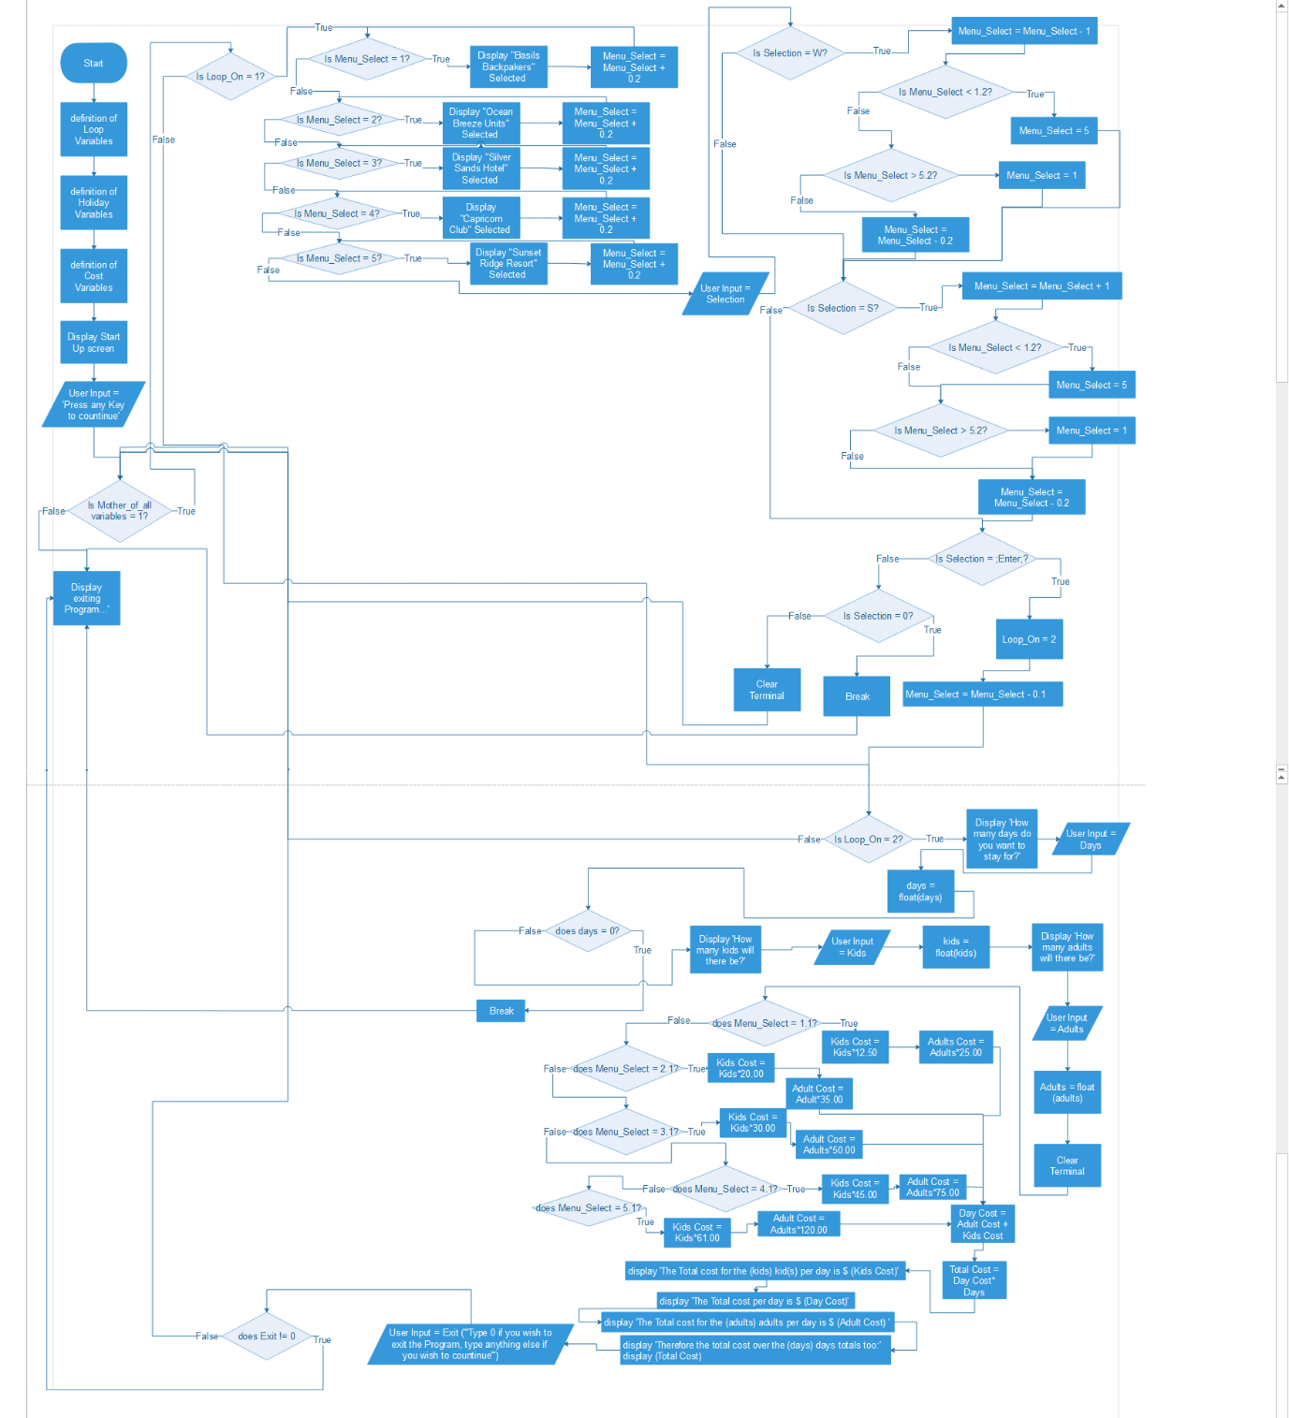

***Example scenarios:***



This scenario is relatively easy to simulate within the program.

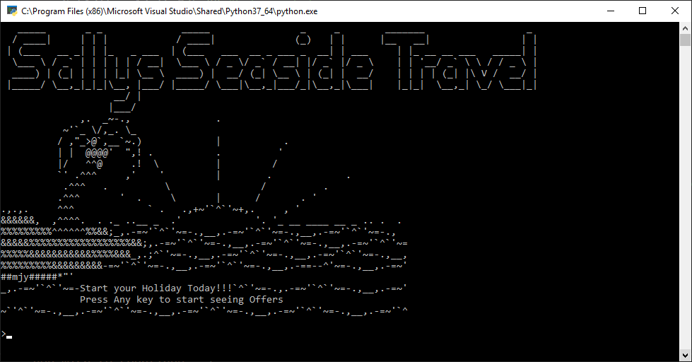

First it would show the starting splash screen, where Mr or Mrs Bloggs would be prompted to press any key, after this the screen is cleared and the first menu is displayed.

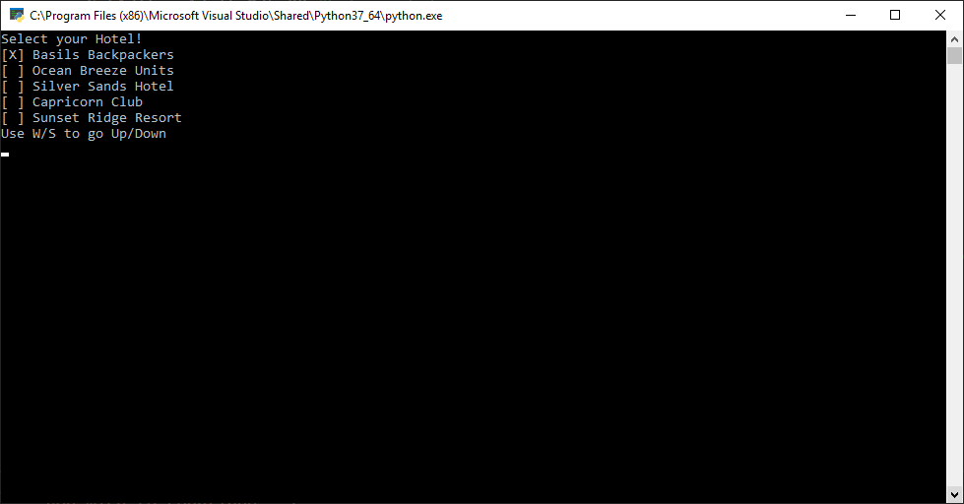

Here we see the first Menu, at this point the program is within the first of the main 2 loops of the program, where the user selects which hotel they want to stay at, using the w/s keys to scroll to their options

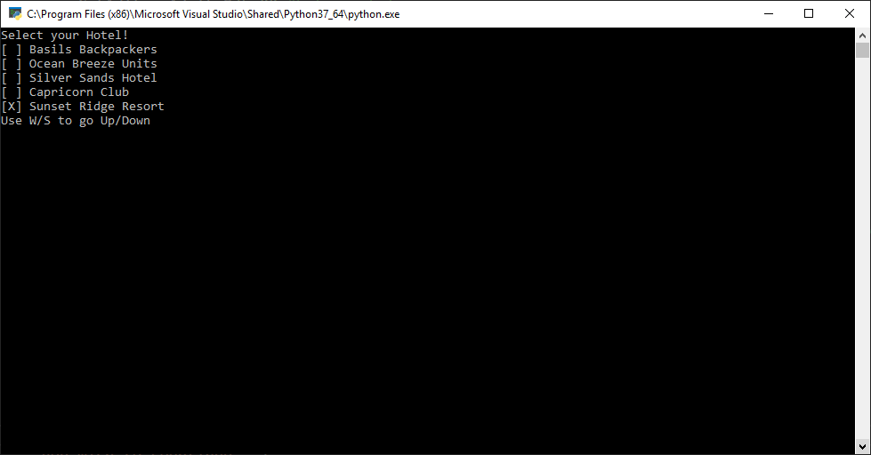

In this case the user scrolls to sunset ridge resort and then presses “Enter” to select the option highlighted.

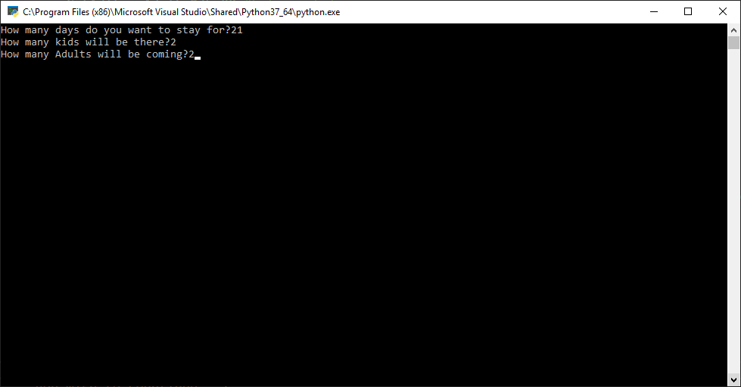

At this point the screen is cleared and the user is asked for the various attributes and fields that are important for the holiday. This screen has them already filled in from the study

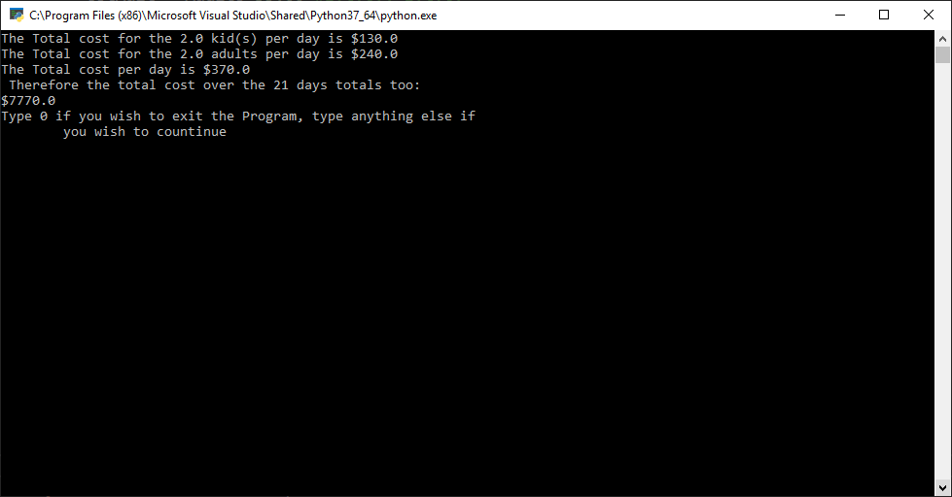

At this point the computer shows the various calculations made with regards to the program, as well as the final cost of all the products. The input then awaits for the users two choices, either type 0 to exit the program, or any other key to restart it and clear the previous variables.

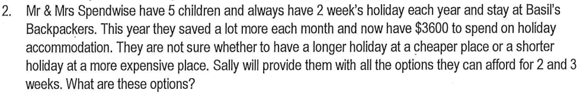

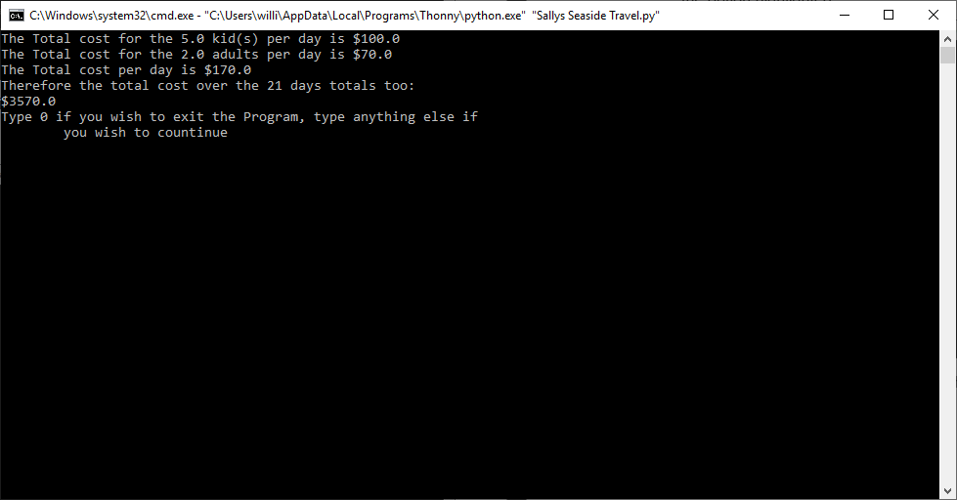

Based on quick brute force, the couple have a choice between either a 21 day stay at *Ocean Breeze Units*, with only $30 dollars left over, or….

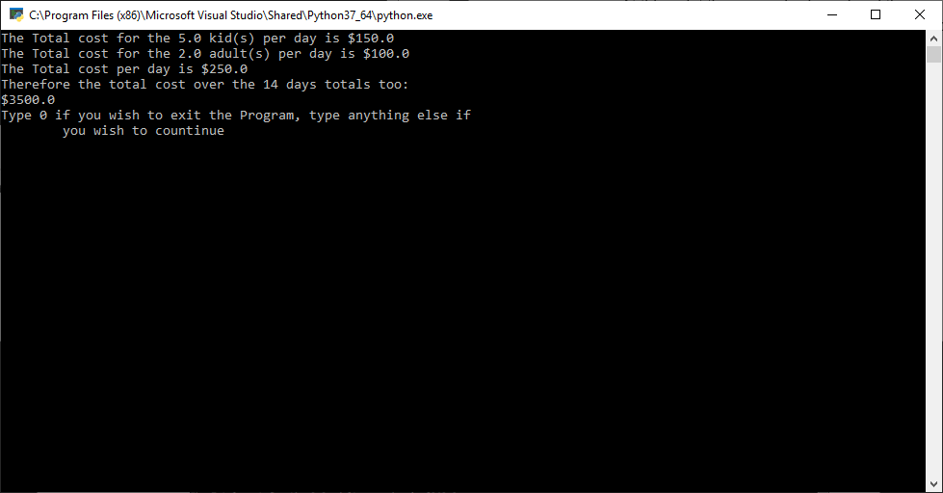

The couple could choose *Silver Sands Hotel* for a shorter 14 day stay, which does, however, provide an extra $100 left over for the couple to spend, but of course a shorter stay.